

Lab 2. Install JBoss Developer Studio
This lab will guide you how to install JBoss Developer Studio and the tools for creating data views that are accessible through standard protocols (the Teiid Designer plug-in for JBoss Developer Studio (JBDS) and connect JBoss Developer Studio to the JBoss Data Virtualization server.
2.1 If you don't already have JBoss Developer Studio 7.1.1, download it by clicking the green download button here: https://www.jboss.org/products/jbds.html
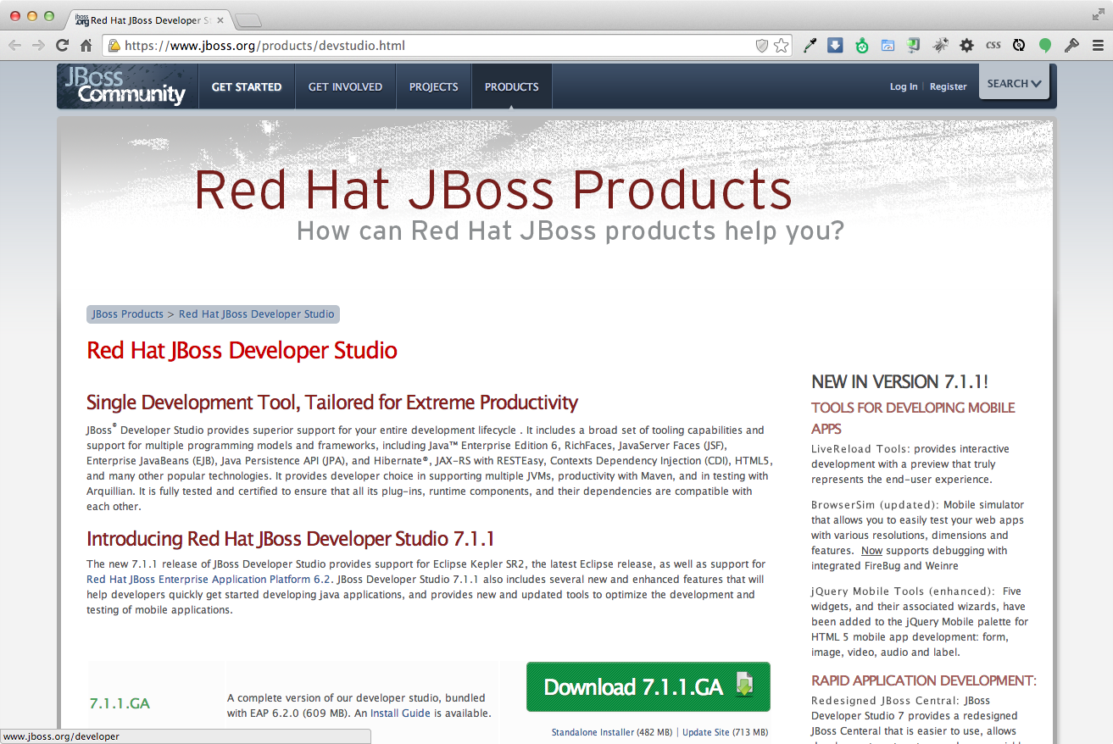

2.2 Run the JBDS installer using java at the command prompt:
java -jar {jbdevstudio-installer.jar}
The current available version is 7.1.1.GA, and to run the installer at the command prompt see below.
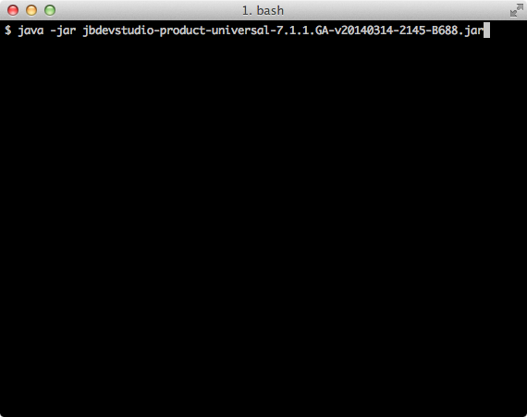

2.3 Follow the installer prompts to complete the installation process.
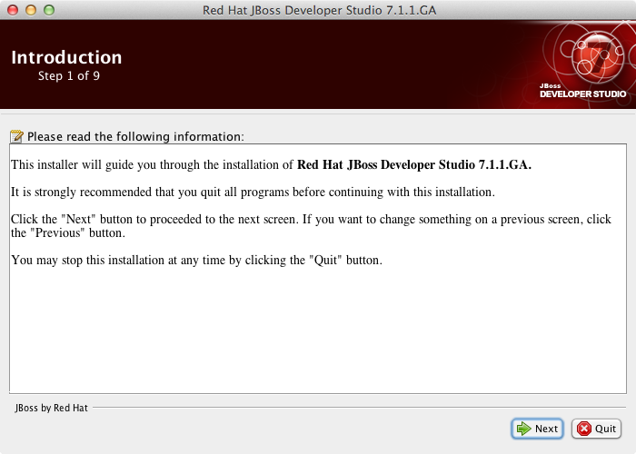
When the Installer window opens, click “Next”.

2.4 After reading and agreeing to the terms of the End User License Agreement, select I accept the terms of this license agreement and click “Next”.
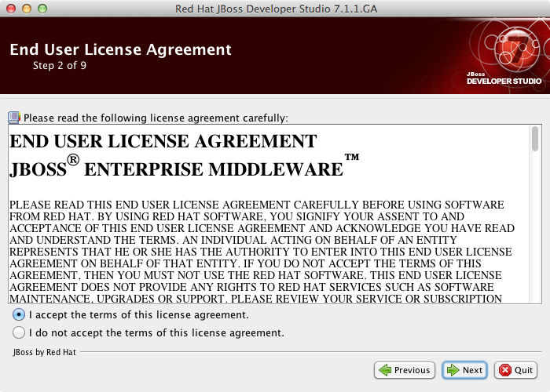

2.5 In the Select the installation path field, type the path where you want JBoss Developer Studio to be installed or click Browse to navigate to the location. When the Select the installation path field shows the correct path, click “Next”.
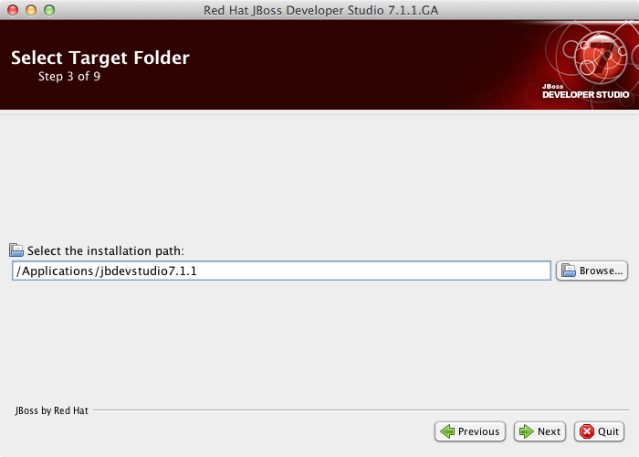

2.6 When you are prompted about the specified location being created or overwritten, review the message and, if satisfied, click “OK” to proceed and press “Next” to continue.
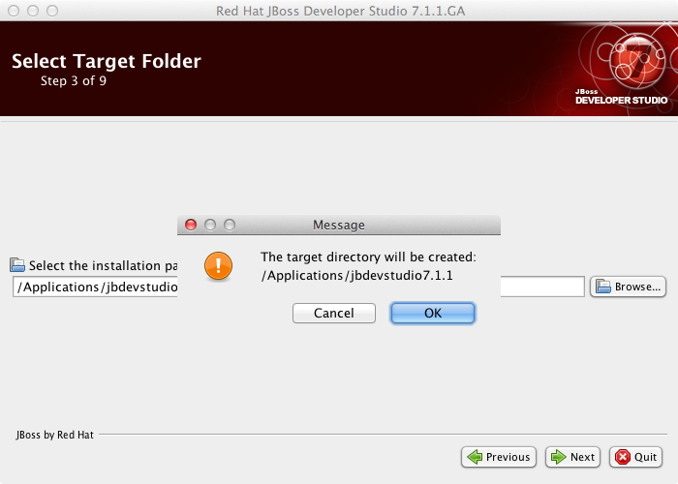

2.7 In the Select Java VM step, Default Java VM is automatically selected. Ensure that the disabled text field contains the path of the Java developer kit you want to use. This is based on the default Java developer kit of your system. To change the specified Java developer kit, select Specific Java VM and type the path of the Java developer kit in the text field or use the Browse button to locate the Java developer kit. When the text field shows the correct Java developer kit path, click “Next”.
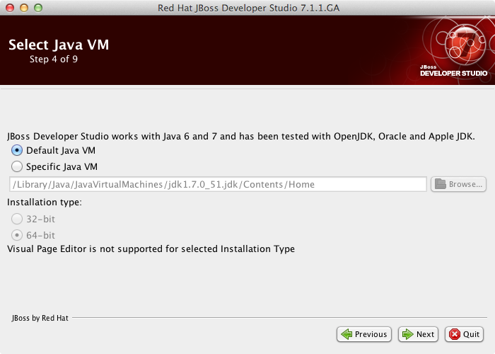

2.8 In the Select Platforms and Servers step one can add server to make use of automatic runtime detection for finding already installed application servers. Skip this for now since we will add servers later. Click “Next” to proceed.
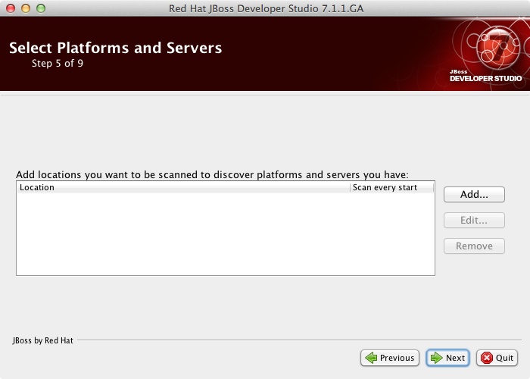

2.9 Review the details in the Summary Information window and, if they are correct, click “Next”. The installation commences.
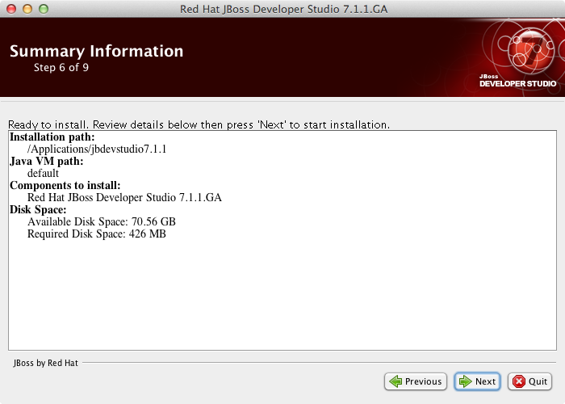
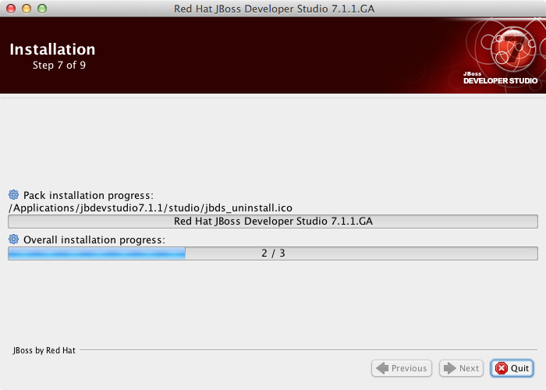

2.10 When the installation progress bar shows Finished, click “Next”.
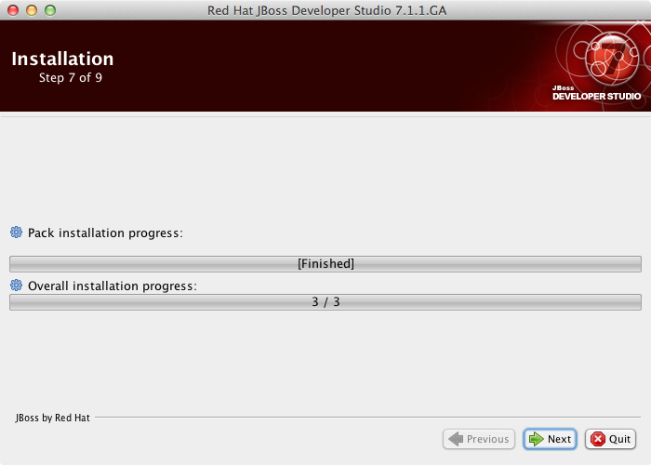
The installation process is now complete.

2.11 To create shortcuts for starting JBoss Developer Studio, select the Create shortcuts in the Start-Menu and Create additional shortcut on the desktop check boxes and click “Next”.
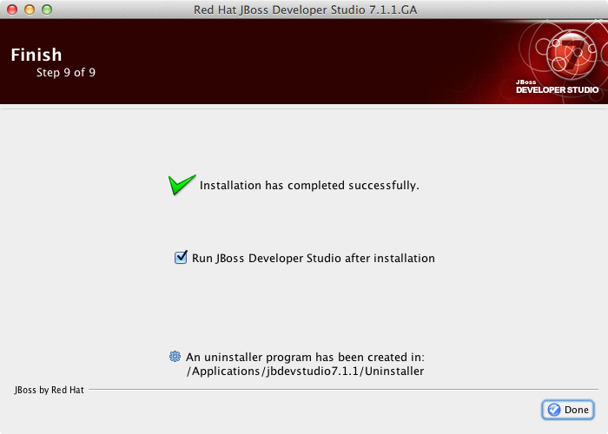
To automatically start JBoss Developer Studio when the Installer window closes, select the Run JBoss Developer Studio after installation check box.
Click “Done” to close the Installer window.

2.12 When the installation is completed, run JBoss Developer Studio 7.1.1. When the JBoss Developer Studio starts, you are asked to choose the workspace folder for the session. The workspace is where your projects are stored.
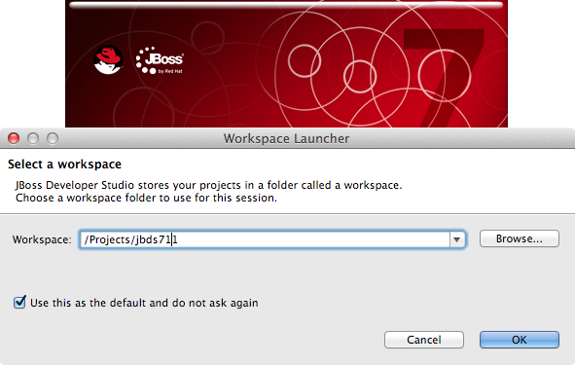

To set the workspace location, follow these steps:
- In the Workspace field, type the path for a new or existing workspace or use Browse to navigate to the workspace location.
- If you do not want to be asked to choose a workspace folder each time the IDE starts, select the Use this as the default and do not ask again check box.
- Click “OK”.
The workspace location prompting behavior can be altered at any time by clicking Window→Preferences. Expand General→Startup and Shutdown and select Workspaces. Select or clear the Prompt for workspace on startup check box to alter the behavior as appropriate.

2.13 From the JBDS menu bar, choose Help->Install New Software...
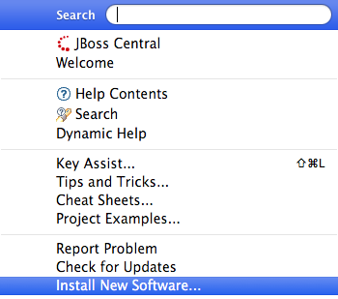

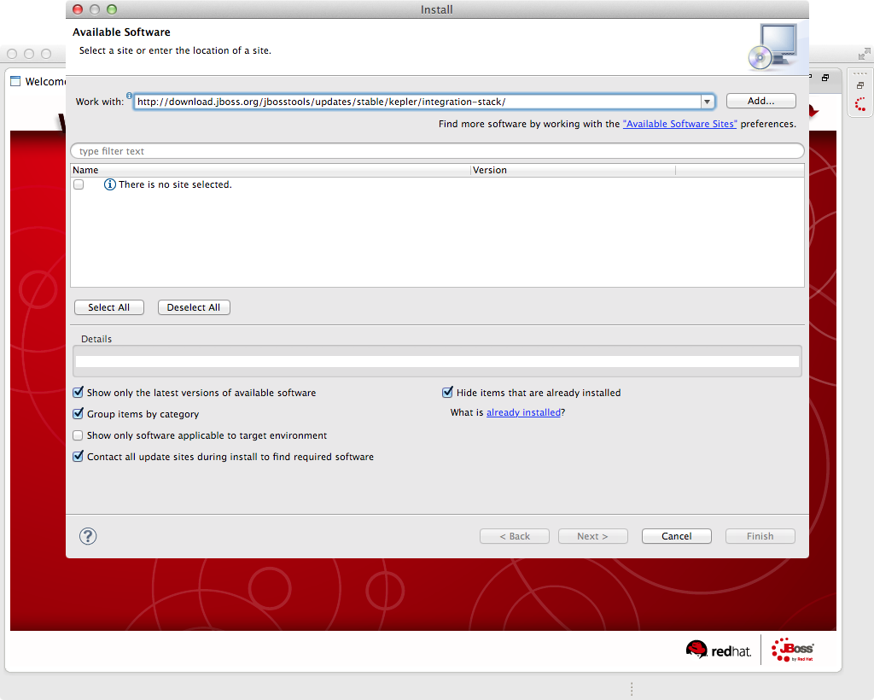
2.14 In the "Work with:" field on the Install wizard, paste the following link: http://download.jboss.org/jbosstools/updates/stable/kepler/integration-stack/
and click the “Add...” button.

2.15 The Add Repository window appears and add an appropriate repository name (i.e. “JBoss Integration Tools”) in the “Name:” field and click the “OK” button.
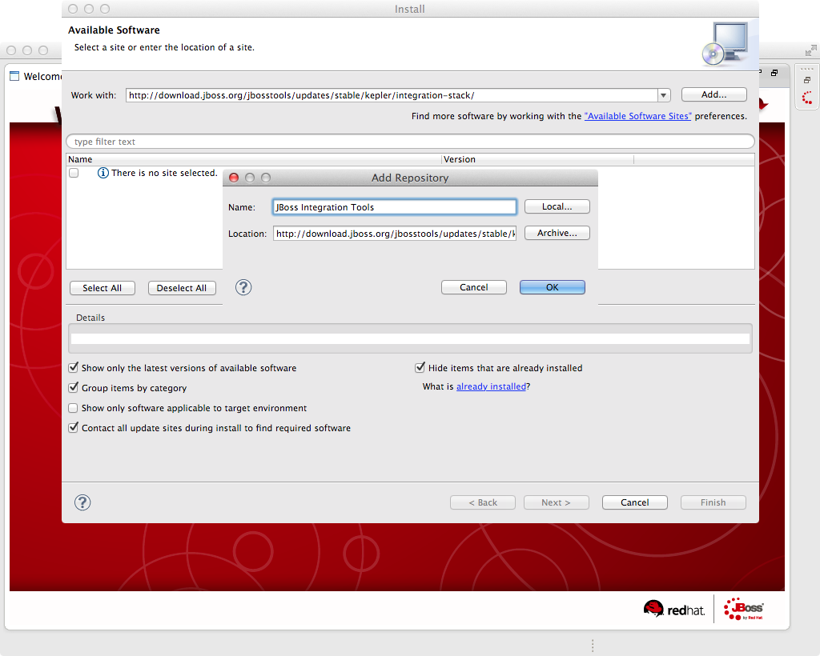

2.16 Select the JBoss Data Virtualization Development option in the list and click “Next”.
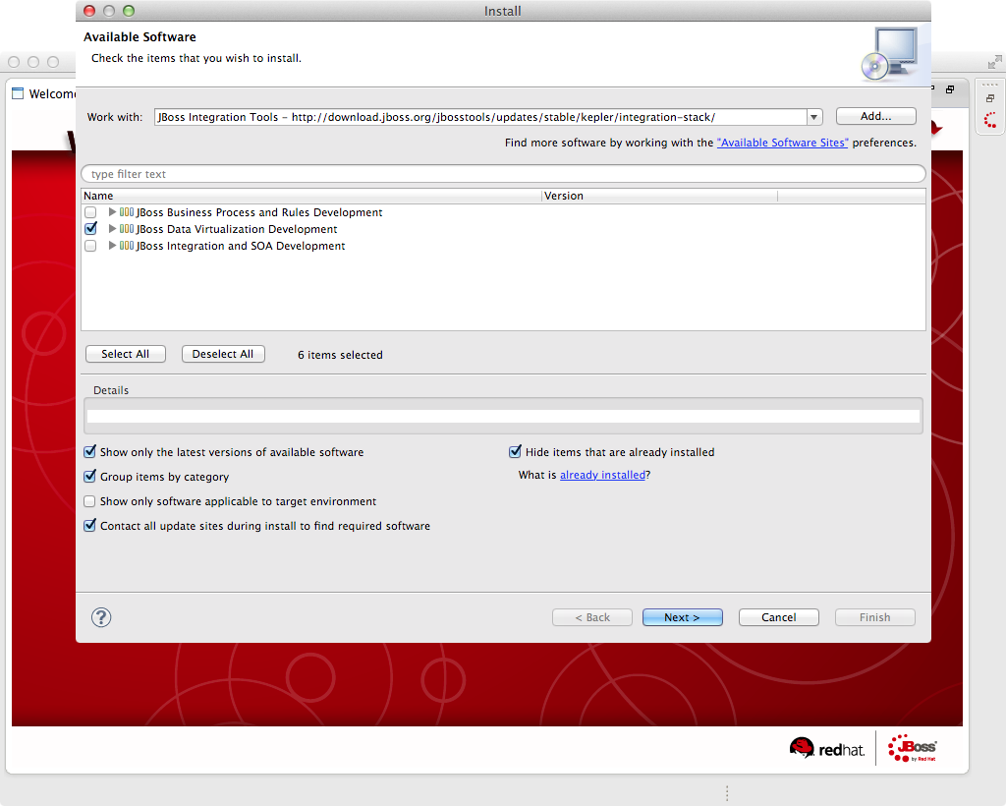

2.17 Review Install Details and click “Next >” button.
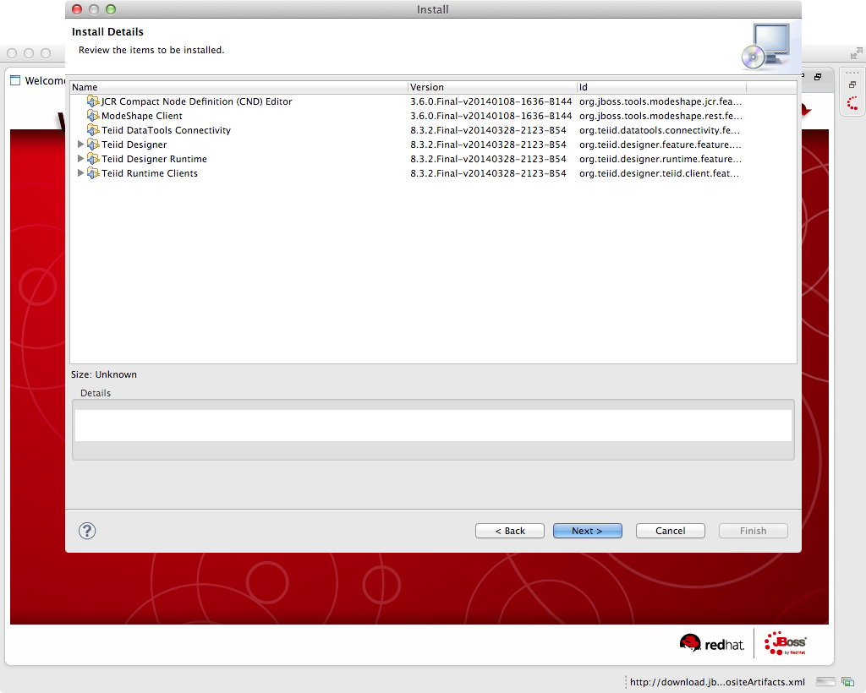

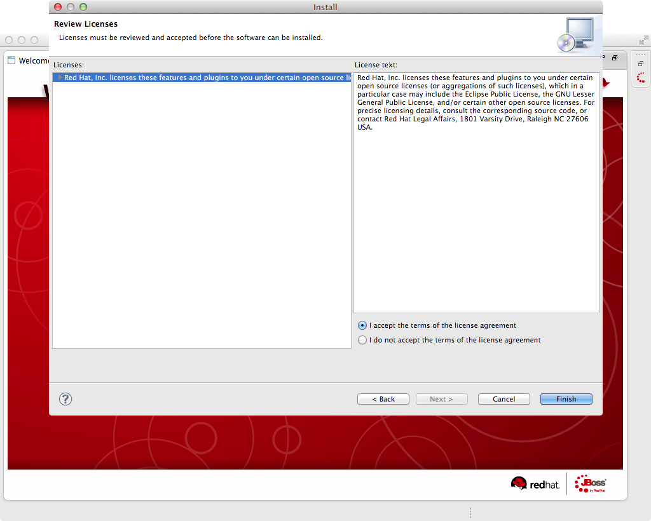
2.18 The Security Warning window appears and click the “OK” button to proceed.
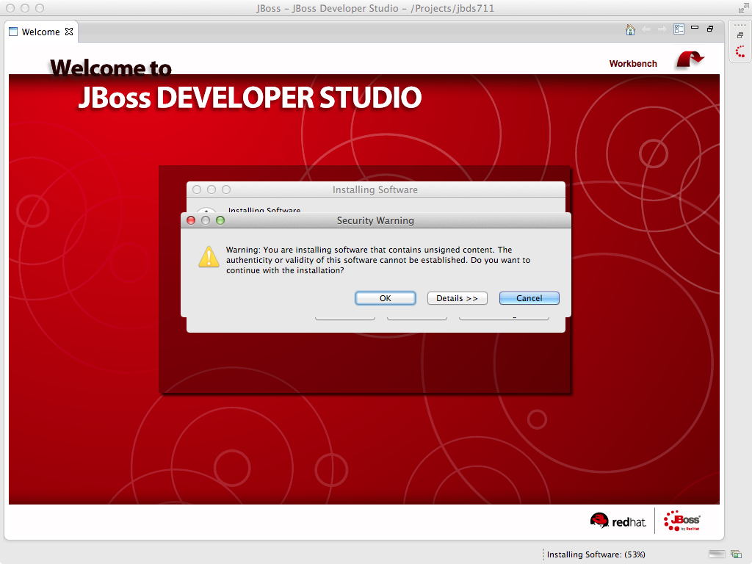

2.19 The Software Updates window appears. Press the “Yes” button to restart JBoss Developer Studio to apply the changes to take effect.
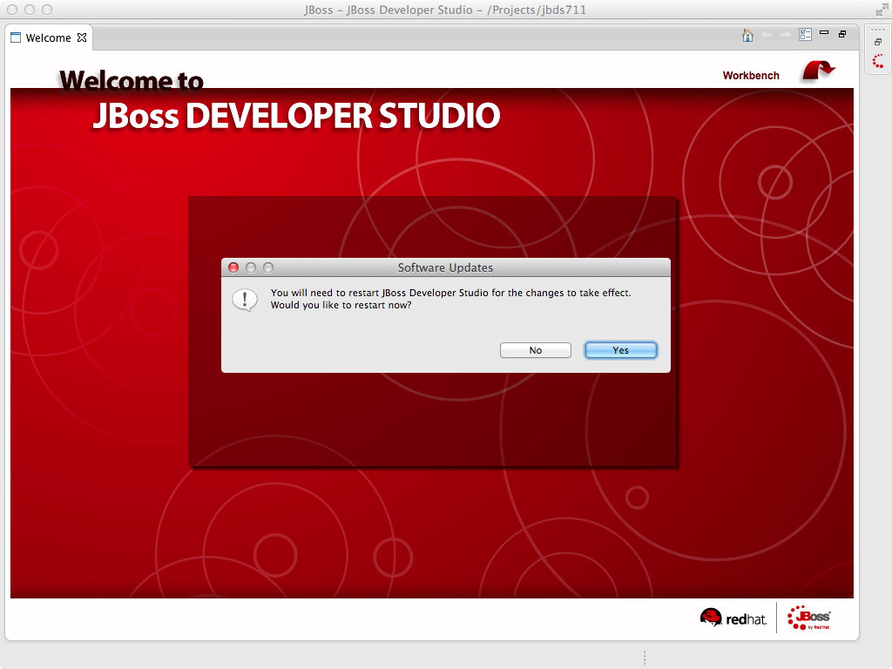
Now that you have JBoss Data Virtualization and JBoss Developer Studio successfully installed, it is time to “hook up” JBoss Developer Studio to the JBoss Data Virtualization server instance.

2.20 If the Servers pane is not already visible in JBoss Developer Studio, you can open it by Window -> Show View -> Other -> Server -> Servers. The Show View window is presented below.
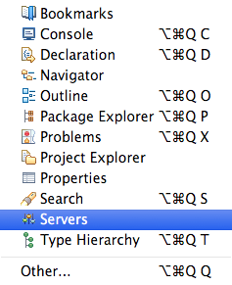

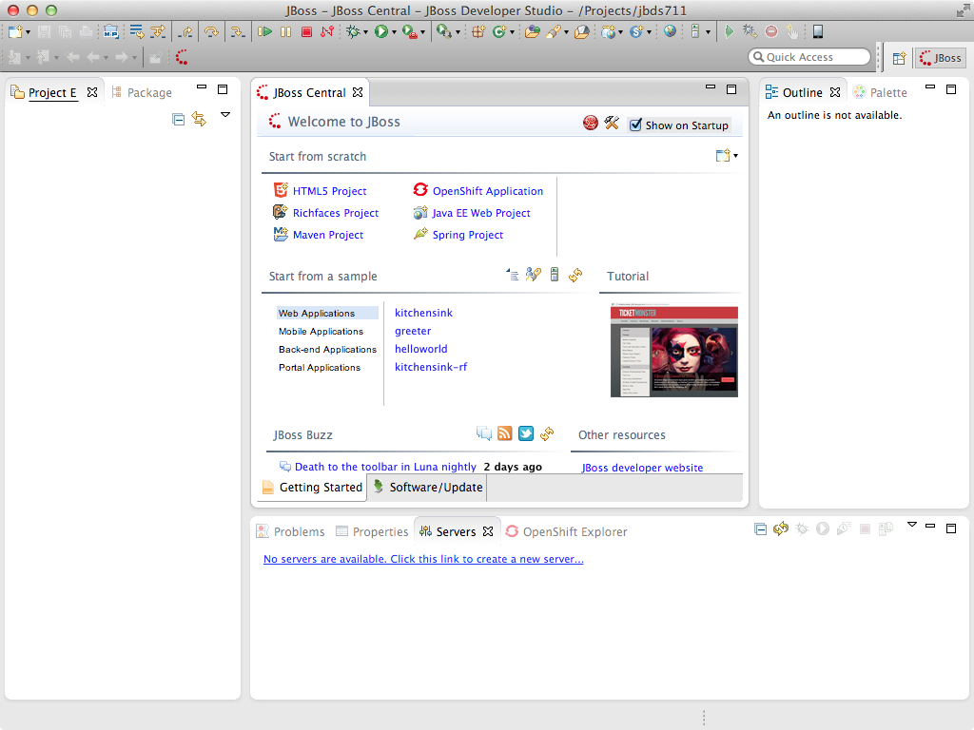
Now, click the “OK” button. The Servers pane will now be visible in the lower portion of JBoss Developer Studio and is displayed below.
2.21 Now, it is a matter of clicking through several screens to add the JBoss Data Virtualization server instance that was installed as part of Lab 1. Click the link “No servers are available. Click this link to create a new server...” and following window will appear:
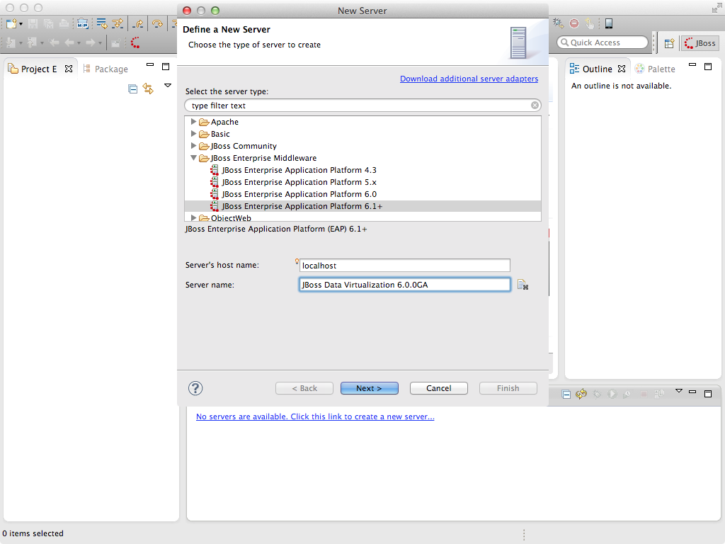
With the New Server wizard enabled, be sure you entries look like those above. Select JBoss Enterprise
Middleware -> JBoss Enterprise Application Platform 6.1+ as the server type. You can keep the defaults that are selected or enter the values appropriate for your workstation. In this case, “localhost” is entered for Server’s host name and “JBoss EAP 6.1+ Runtime Server” is entered for the Server name. Change the Server name into a meaningful name. Click the “Next” button.
Next, the JBoss Runtime will need to be defined. Essentially, this is selecting the “home” directory for the JBoss Data Virtualization instance that was installed as part of Lab 1. The values to select are illustrated below.
Select the “home” directory for the JBoss Data Virtualization instance. This will be <path to installed instance>/jboss-eap-6.1. Once this runtime is selected, the available configurations are available. To keep things simple, select the “default” profile.
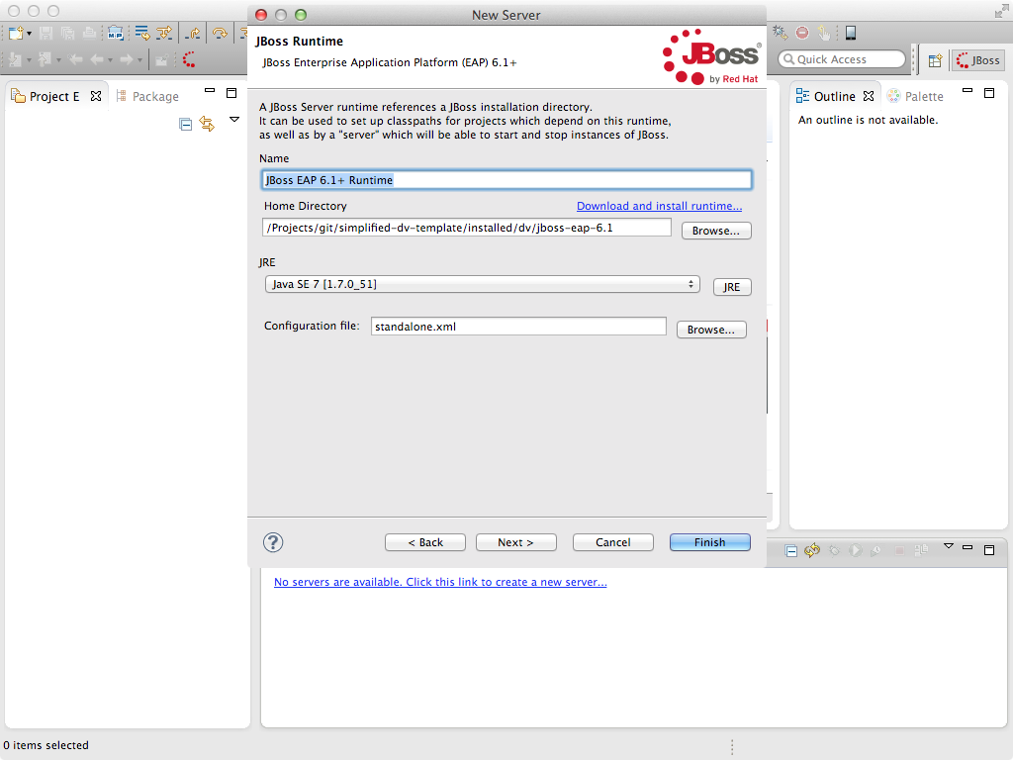
Click “Finish”.

The Servers pane will now have the available server available as indicated below.
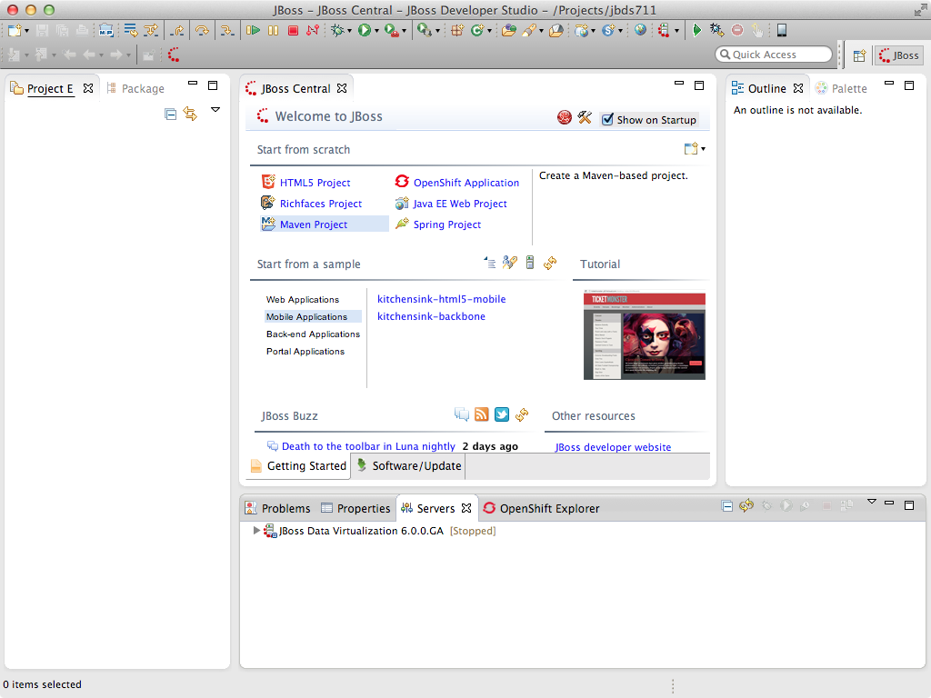
At this point, you can right-click on the server and there is a list of available options. Click “Start” from the available options and the server will start up.
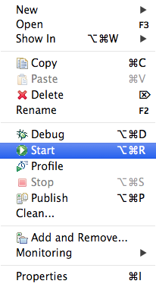

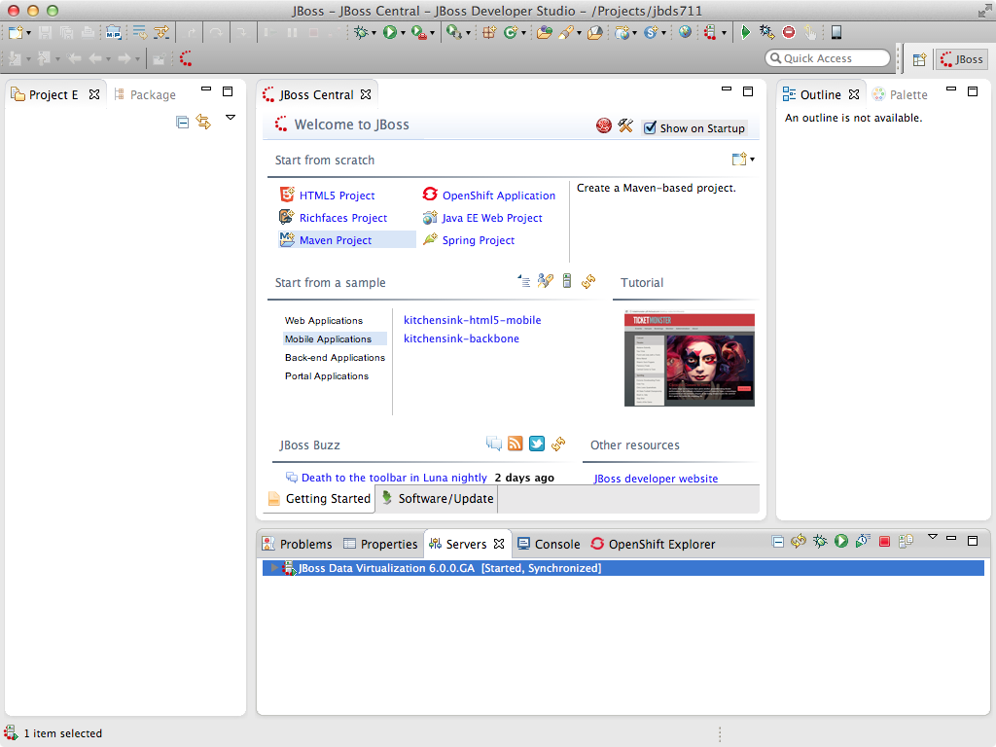
You can now begin creating your own JBoss Data Virtualization projects.
Congratulations, you have completed Lab #2.

